NAME : TASNEEM SADIKOT
PRN : 23070521162
SEM : 4 SECTION : B

Lab 8
PL/SQL Procedure for Fund Transfer
Step 1: Create Database Tables
1.1 Create accounts Table
CREATE TABLE accounts (
account_no NUMBER PRIMARY KEY, -- Unique account number as the primary key
holder_name VARCHAR2(100), -- Name of the account holder
balance NUMBER(10,2) CHECK (balance >= 0) -- Account balance, ensuring it cannot be negative
);

1.2 Create transactions Table
CREATE TABLE transactions (
transaction_id NUMBER GENERATED BY DEFAULT AS IDENTITY PRIMARY KEY, -- Unique transaction ID, auto-incremented
from_account NUMBER, -- Account number from which the amount is debited
to_account NUMBER, -- Account number to which the amount is credited
amount NUMBER(10,2), -- Transfer amount with two decimal places
transaction_date TIMESTAMP DEFAULT SYSTIMESTAMP -- Date and time of the transaction, defaulting to the current timestamp
);
Step 2: Insert Sample Data

INSERT INTO accounts VALUES (101, 'Alice', 5000.00); -- Adding account 101 for Alice with ₹5000 balance
INSERT INTO accounts VALUES (102, 'Bob', 3000.00); -- Adding account 102 for Bob with ₹3000 balance

COMMIT; -- Saving the changes permanently in the database

Step 3: Write PL/SQL Procedure
CREATE OR REPLACE PROCEDURE transfer_funds(
p_from_acc NUMBER,
p_to_acc NUMBER,
p_amount NUMBER
) AS
v_balance NUMBER;
BEGIN
-- Check if sender has sufficient balance
SELECT balance INTO v_balance FROM accounts WHERE account_no = p_from_acc;
IF v_balance < p_amount THEN
RAISE_APPLICATION_ERROR(-20001, 'Insufficient balance.'); END IF;
-- Deduct amount from sender
UPDATE accounts SET balance = balance - p_amount WHERE account_no = p_from_acc;
-- Add amount to receiver
UPDATE accounts SET balance = balance + p_amount WHERE account_no = p_to_acc;
-- Log transaction
INSERT INTO transactions (from_account, to_account, amount) VALUES (p_from_acc, p_to_acc, p_amount);
-- Commit transaction
COMMIT;
DBMS_OUTPUT.PUT_LINE('Transfer successful.');
EXCEPTION
WHEN NO_DATA_FOUND THEN
RAISE_APPLICATION_ERROR(-20002, 'Invalid account number.');
WHEN OTHERS THEN
ROLLBACK;
RAISE_APPLICATION_ERROR(-20003, 'Transaction failed: ' || SQLERRM);
END;
/
Step 4: Execute Procedure
BEGIN
transfer_funds(101, 102, 1000); -- Transferring ₹1000 from Alice's account (101) to Bob's account (102)
END;
/
Step 5: Verify Results
Check Account Balances
SELECT * FROM accounts;
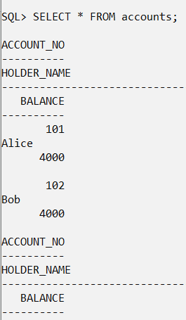
Check Transactions Log
SELECT * FROM transactions;
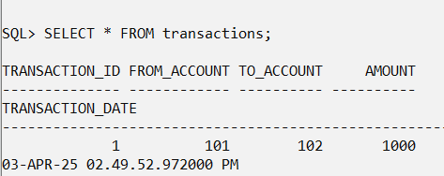
Task: Fund Transfer Validation and Execution
Task 1: Check Account Balance Before Transfer - Write a PL/SQL block that takes an account number as input and displays the account balance.
Hint: Use SELECT balance INTO inside a PL/SQL block and DBMS_OUTPUT.PUT_LINE to display the balance. 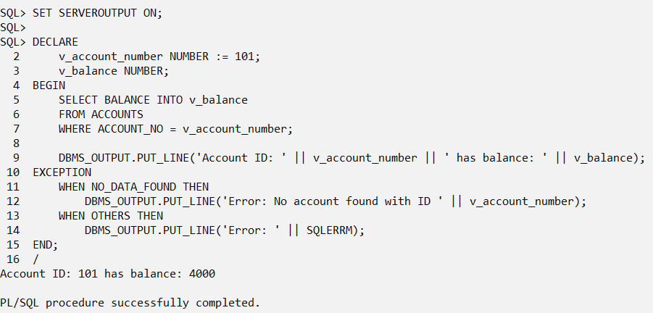
Task 2: Execute Fund Transfer Procedure - Call the transfer_funds procedure to transfer ₹500 from account 101 to account 102.
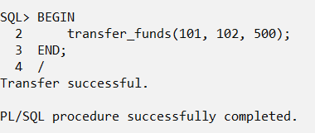
Hint: Use the BEGIN...END; block to execute the procedure.
Task 3: Validate Transaction Log - After executing the transfer, write an SQL query to display all transactions recorded in the transactions table.
Hint: Use SELECT * FROM transactions; to verify the transaction details.
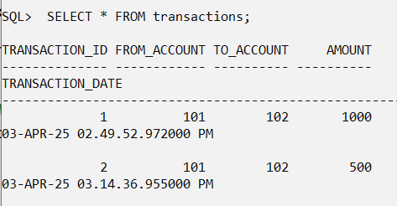
Task 4: Check Transaction History for a Specific Account
Write a PL/SQL block that takes an account number as input and displays all transactions (both sent and received) related to that account.
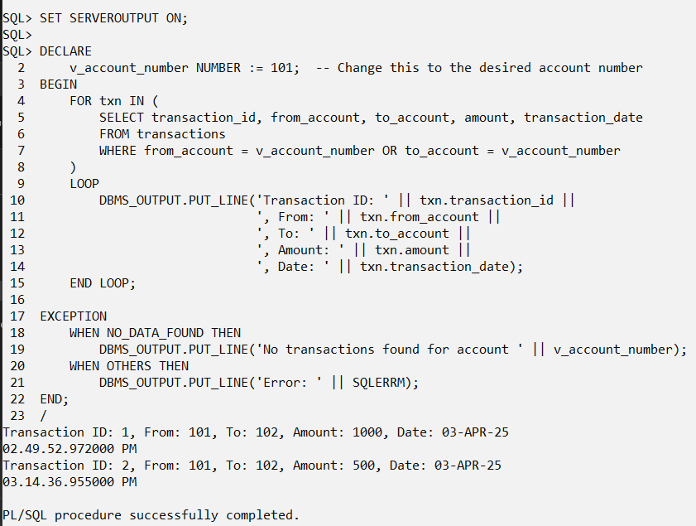
Hint: Use SELECT * FROM transactions WHERE from_account = acc_no OR to_account = acc_no; inside a PL/SQL block.

Task 5: Prevent Self-Transfer
Modify the transfer_funds procedure to prevent an account from transferring money to itself. If the sender and receiver accounts are the same, raise an error message.
Hint: Add a condition inside the procedure:
IF p_from_acc = p_to_acc THEN
RAISE_APPLICATION_ERROR(-20004, 'Sender and receiver cannot be the same.');
END IF;
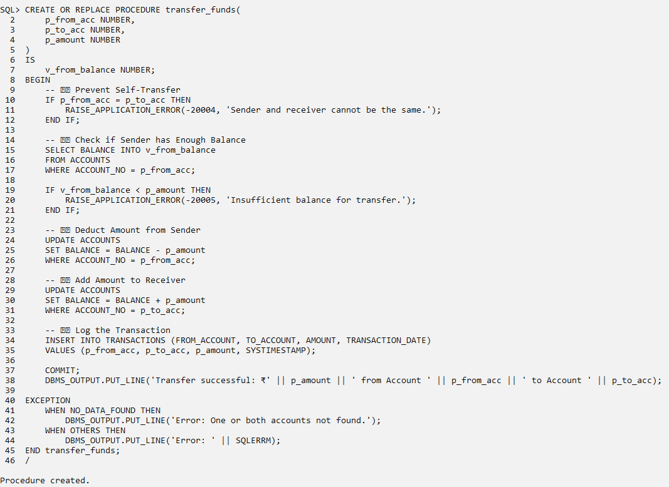
Task 6: Create a Function to Check Account Balance
Write a PL/SQL function named get_balance that takes an account number as input and returns the current balance.
Hint:
CREATE OR REPLACE FUNCTION get_balance(p_acc_no NUMBER) RETURN NUMBER AS
v_balance NUMBER;
BEGIN
SELECT balance INTO v_balance FROM accounts WHERE account_no = p_acc_no;
RETURN v_balance;
END;
/
Call it using:
SELECT get_balance(101) FROM dual;
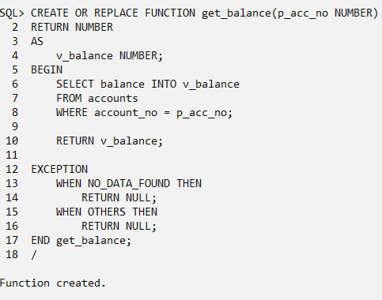
Task 7: Implement a Transfer Limit
Modify the transfer_funds procedure to set a maximum transfer limit of ₹10,000 per transaction. If a user tries to transfer more than this amount, raise an error.
Hint: Add a condition:
IF p_amount > 10000 THEN
RAISE_APPLICATION_ERROR(-20005, 'Transfer amount exceeds the limit of ₹10,000.');
END IF;
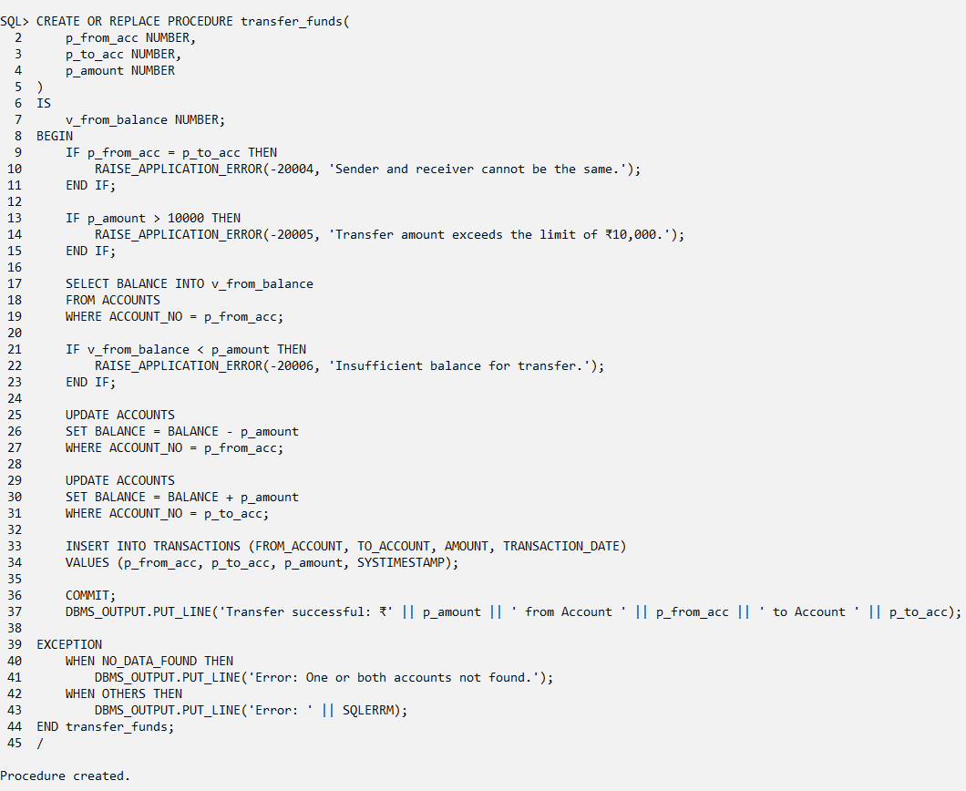
Task 8: Generate a Monthly Statement
Write a PL/SQL procedure that takes an account number and a month-year (e.g., 04-2025) as input and displays all transactions for that month.
Hint: Use TO_CHAR(transaction_date, 'MM-YYYY') in the WHERE clause:
SELECT * FROM transactions
WHERE (from_account = acc_no OR to_account = acc_no)
AND TO_CHAR(transaction_date, 'MM-YYYY') = '04-2025';
